 | 35.3 Addon - Bforartists 3D Sequencer
Table of content
Bforartists Power User Tools 1
Animation Operators 1
Insert Keyframe Left 2
Location 2
Insert Keyframe Right 2
Location 2
Use 2
1. Activate the addon 3
2. Customize which operators you would need 3

Bforartists Power User Tools
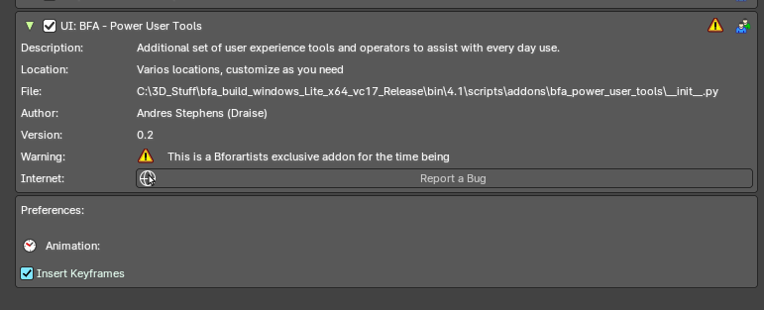
This addon is optional and deactivated by default.
This is an addon with an additional set of user experience tools and operators to assist every day use.
This addon is thanks to Draise.

Note
To activate/deactivate an addon, go to Edit – Preferences – Addons tab – and untick any activated addons.
If you’d like to keep your addons for future use, you can either save the preferences, or activate them on demand per workspace in the workspace settings in the property shelf.

Animation Operators
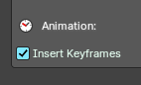
These are operators to assist and improve the animation user experience.

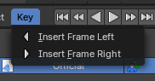
Insert Keyframe Left
Inserts an empty frame and nudges all keyframes to the left of the time cursor. Useful for grease pencil and stop motion animation.

Location
3D View Editor – Object Header Menu – Animation Sub-Menu
Timeline Editor – Key Header Menu
Dopesheet Editor – Key Header Menu
Graph Editor – Key Header Menu

Insert Keyframe Right
Inserts an empty frame and nudges all keyframes to the right of the time cursor Useful for grease pencil and stop motion animation.

Location
3D View Editor – Object Header Menu – Animation Sub-Menu
Timeline Editor – Key Header Menu
Dopesheet Editor – Key Header Menu
Graph Editor – Key Header Menu

Use

1. Activate the addon
In the user preferences Addons tab, search for “Power User” and activate the addon.
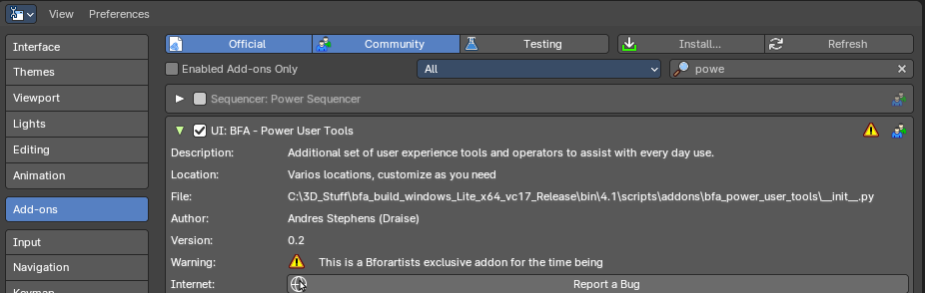

2. Customize which operators you would need
Here you will find categories and groups of operators. Mouse over which group of operators to see the tooltip to learn more.

